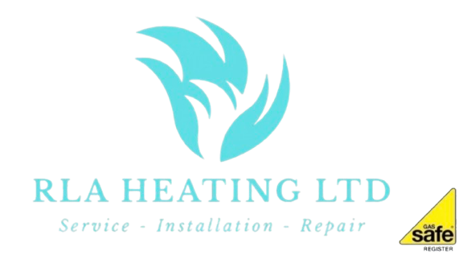
RLA Heating Ltd – Complaints Policy
1. Purpose
At RLA Heating Ltd, we are committed to delivering high-quality plumbing and heating services. If something goes wrong, we want to hear from you so we can resolve the issue quickly and improve our services.
2. What is a Complaint?
A complaint is any expression of dissatisfaction regarding our workmanship, customer service, communication, or any aspect of our services.
3. How to Make a Complaint
Customers can make a complaint using any of the following methods:
- Email: info@rlaheating.co.uk
- Telephone: 01420 579018
- In writing: 16, Empire Walk, Bordon, Hampshire GU35 0GA
- In person (where applicable)
To help us investigate your complaint, please provide:
- Your full name and contact details
- Job address (if different)
- Details of the work carried out
- A clear description of the issue
- Photos or documents (if relevant)
- Your preferred outcome
4. Acknowledgement of Complaint
We will acknowledge your complaint within 3 working days of receipt.
5. Investigation Process
We will:
- Review the details of your complaint
- Assess any work carried out
- Contact you if further information is required
- Arrange a site visit if necessary
We aim to handle all complaints fairly, promptly, and professionally.
6. Response Time
We aim to provide a full response within 10 working days. If more time is needed (for example, to inspect work or obtain parts), we will keep you informed throughout the process.
7. Resolution
Where a complaint is upheld, we will aim to resolve the issue by:
- Carrying out remedial work
- Offering a repair or replacement where appropriate
- Providing a partial or full refund (if applicable)
- Offering an apology and explanation
8. Escalation
If you are not satisfied with our response, you may request that your complaint is reviewed by a senior member of RLA Heating Ltd.
Where applicable, you may also seek independent advice or refer the matter to an alternative dispute resolution (ADR) provider.
9. Guarantees and Workmanship
All work carried out by RLA Heating Ltd is covered by relevant guarantees. Complaints relating to workmanship will be assessed in line with these guarantees.
10. Confidentiality
All complaints will be treated in confidence and handled in accordance with data protection regulations.
11. Continuous Improvement
We take all complaints seriously and use them to improve our services, staff training, and customer experience.
12. Contact Details
RLA Heating Ltd
16, Empire Walk, Bordon, Hampshire, GU35 0GA
01420 579081
Info@rlaheating.co.uk

This policy is reviewed regularly to ensure it remains effective and up to date.

